KB Article #2746
Customer Support Note: A feedback template can be found at the bottom of this article, which can be used if the customer contacts OEConnection via e-mail about a using Mitchell 1.
Note: Mitchell 1 is currently in the pilot phase with select shops. The general release will be available later in September.
Use the following process when integrating the RepairLink Shop with Mitchell 1:
Step 1: Download the RepairLink Catalog
- Close Mitchell 1.
- Launch the Mitchell 1 Catalog Installer site: http://m1faqs.com/fix/SE/catalogs/.
- Click the REPAIRLINK link to download.
- Once the installer downloads, double click the repairlink.exe to start.

- Click Run.
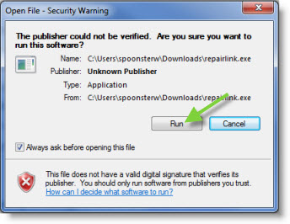
- The installation confirmation window will display, click OK.
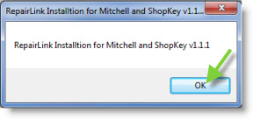
- The WinZip Self-Extractor window will display, click Setup.
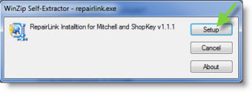
- The installation process will run. Once completed, relaunch Mitchell 1.
Step 2: Enable the RepairLink Shop Catalog Option
Next, you will need to enable the RepairLink Shop catalog option so that the button becomes visible on Order/Revision windows and Setup Link parameter is made available. (You will need your RepairLink Shop Username and Password to complete the activation process.)
- The Manager SE program must on the home “splash” window to access Special Maintenance functions. Clicking on WIP button will toggle the view to display the home window.
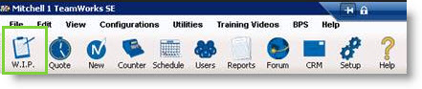
- Click the Configurations menu.
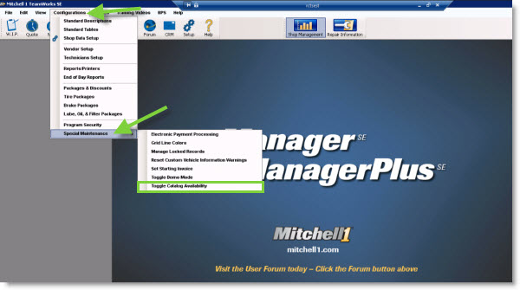
- Select the Special Maintenance option.
- Choose the Toggle Catalog Availability option.
- The Catalog Selector window will display. Click the grey block next to the RepairLink Shop list option.
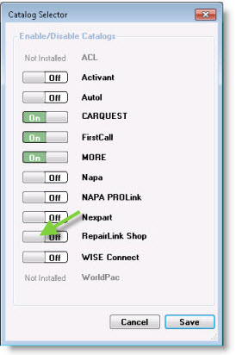
- This will change to On.
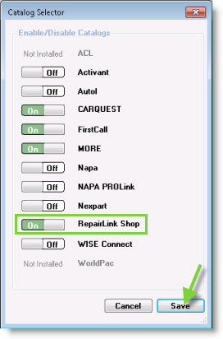
- If the MORE catalog is set to On, click the grey block to turn this option off.

- Click Save to record the selection and close the window. You will now need to create a vendor record and configure the setup link to associate the catalog and credentials to the RepairLink Shop catalog button.
Step 3: Setting up a Linked Vendor Record
- Click the Configurations menu.
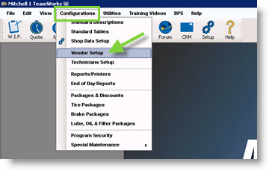
- Select the Vendor Setup option.
- The Vendor Setup window will display. Click Add to create a new Vendor record. (If you need to verify an existing vendor set up, click Edit.)
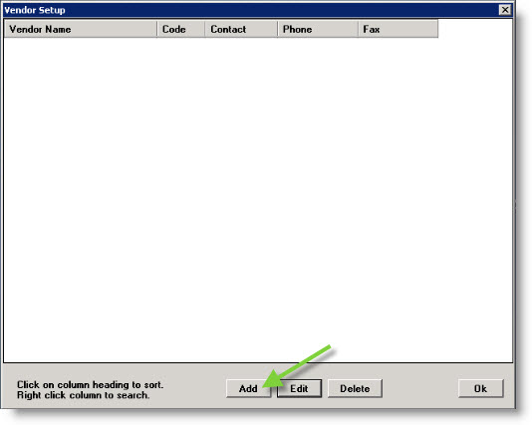
- The Add Vendor window will display. Type the Vendor information in the provided fields to complete the profile. (Code and Name are required fields.)
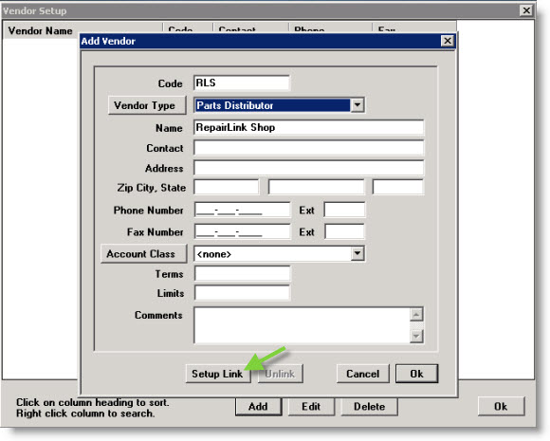
- Click Setup Link.
- The Link Type Selection window will display. Click the Setup RepairLink Shop Catalog Link entry to highlight. Note: This option will only be visible if turned on in Special Maintenance – Toggle Catalog Availability as described in Step 1.
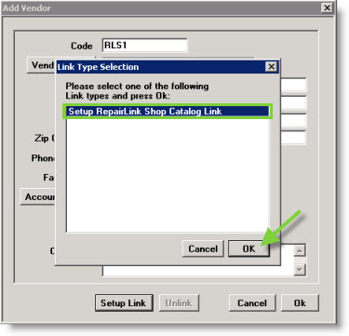
- Click OK.
- The Setup RepairLink Shop Catalog Link window will display. Type your RepairLink Shop Username and Password in the provided fields. Do not change the URL unless directed by Mitchell 1 support to do so.Customer Support Note: If a customer who used this integration does not know their Username and Password, these can be copied from the Setup MORE Catalog.
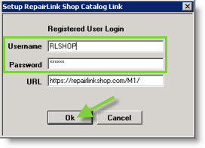
- Click Ok.
- Click Ok to close the Add Vendor window.
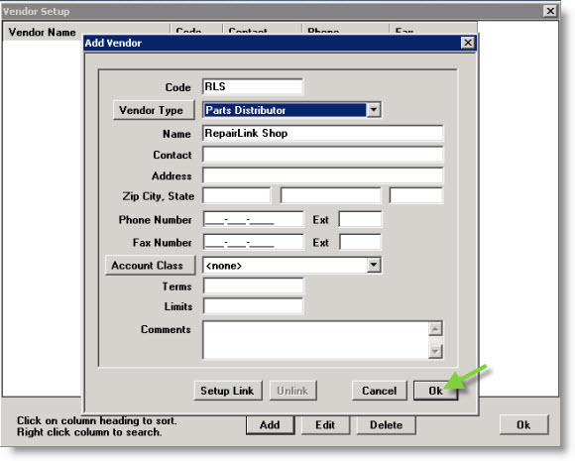
- Click Ok to close Vendor Setup window.
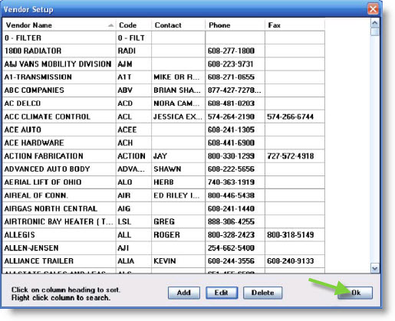
The button will now be active and available to use on the Order and Revision windows.

