CONSIGNMENT PROCESS
Step 1:
Create Consignment Inventory Part in Inventory Materials.

Step 2:
Replenish the inventory item. (Important: Remember you have not bought this item yet therefore it is being replenished, not received or purchased). (See Fig 1 below)

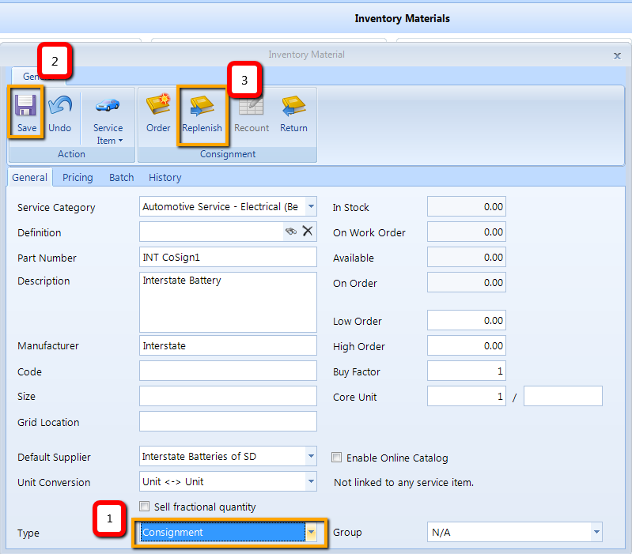
-FIG 1-
The slip number can be whatever you want it to be so you can easily find the items when the supplier gives you the bill after you sell the part. A suggestion would be “consignment” or if the supplier gives you a consignment slip you can use that number (this is not an invoice number). (See FIG 2 below)

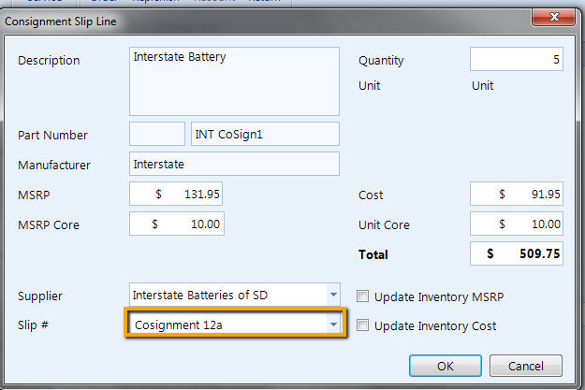
-FIG 2-

Note: The system will create a copy of the “Consignment Slip” in the Purchases module.

Step 3:
Sell the consigned part on a Posted Invoice.

Step 4:
An entry is automatically created for the Supplier under Consignment Sold in the Purchases module. (See FIG 3 below)

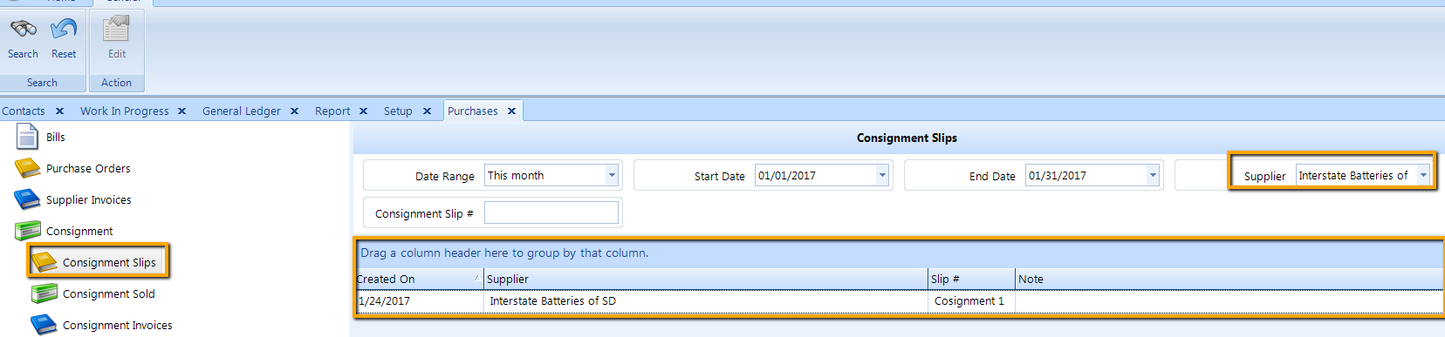
-FIG 3-

Note: The system will relieve the consignment slip of the part sold.

Step 5:
As your Supplier Replenishes your stock they will also Invoice you for the part you have sold.

Step 6:
Locate the part under Consignment Sold in Purchases module | Click Create Invoice on the ribbon (See FIG 4 below)

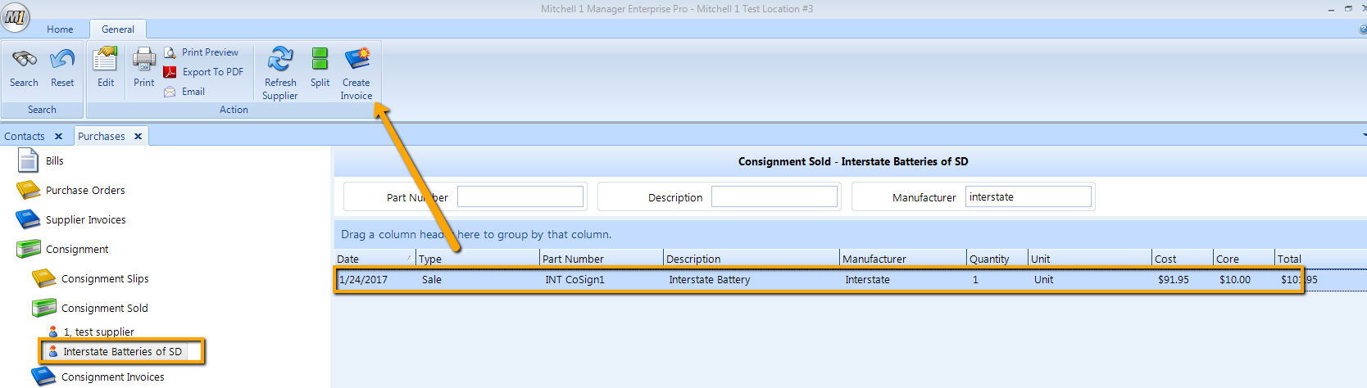
-FIG 4-

Enter Invoice Number from the Supplier Invoice that your supplier has billed the part on.

Step 7:
Locate invoice under Consignment Invoices in Purchases module. (See FIG 5 below)

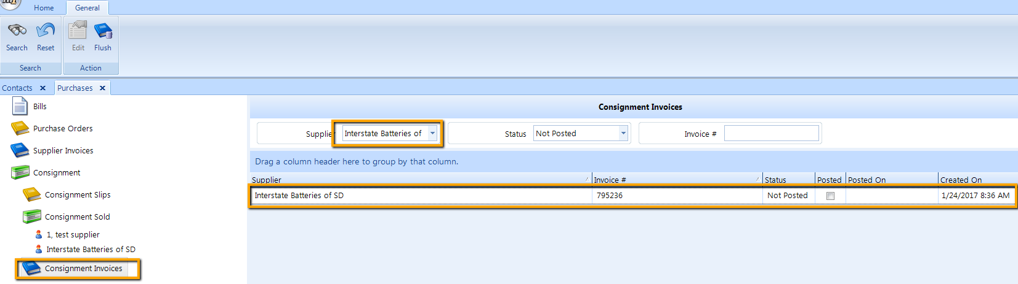

-FIG 5-
Step 8:
Double click to open Supplier Invoice| Post from the ribbon ( See FIG 6 below)

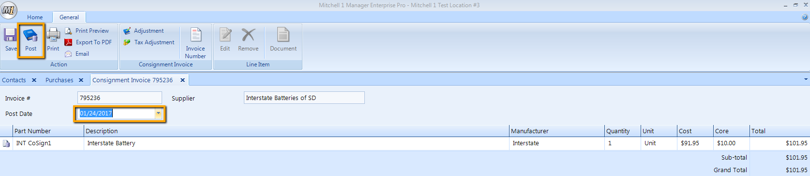
-FIG 6-

Invoice is now moved to the Payable Account (Interstate of SD) to be paid with the statement.

