Inventory Transfers

Inventory transfers for multi locations must be turned on at the back end so you will first need to notify that you would like to use this feature. Please be advised that this is still a work in progress and is not advised to add all stores in your Enterprise Network as it may slow up your search.

To add locations to the network:

- Go to Setup from the home ribbon
- Type network in the search box then highlight it
- Click Add on the ribbon
- Enter name ( i.e., Inventory Transfers, etc)
- Go to Action button bottom left corner
- Click Add
- Enter the name of the shop/location
- Click on search
- Select it from the list
- Click ok
- Continue the steps above to add each location
- When finished click ok
- You will need to do the same steps at each location you are setting up to do Inventory Transfers

Follow these steps to do an inventory transfer:

- Go to Utilities on the home ribbon and click on the drop down arrow
- Select Inventory
- Enter the Search information ( Part number, description, etc) and Enter
- Highlight the correct part
- Go to Search on the ribbon and click on the drop down arrow
- Select Inventory Transfers
- You will now see another column called Network which will show you the quantity at each of the other locations ( see image below)

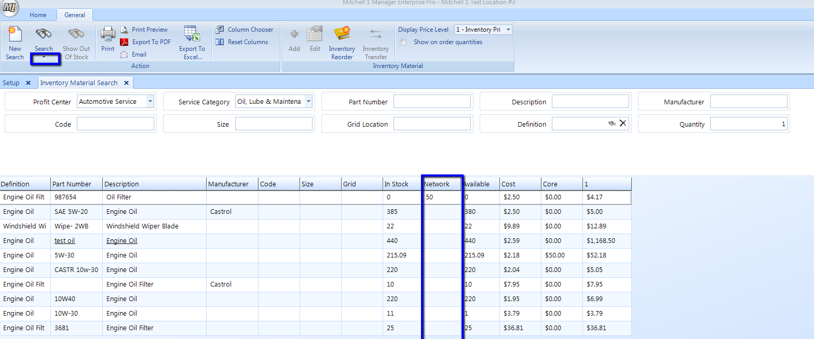

- Highlight the part line item then click Inventory Transfer from the ribbon
- Choose the Location to request from by checking the box next to it
- Select Next
- Enter Quantity
- Click Finish
- A prompt will appear showing the inventory to be transferred Location(s), Qty, and Number
- Select Send Right Now or Save for Later

To verify the process:

- Go to Purchases Module from the ribbon
- Outgoing Requests to see the outgoing request is in progress and has been sent (see image below)

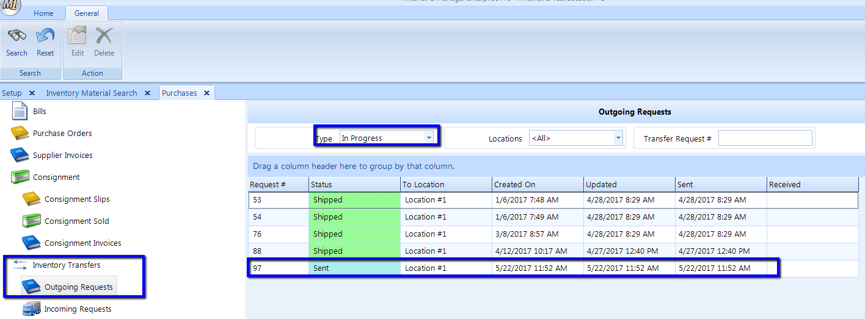

Location that you sent the request to will see an Instant Message notification on the home ribbon to alert them of the request (see image below)

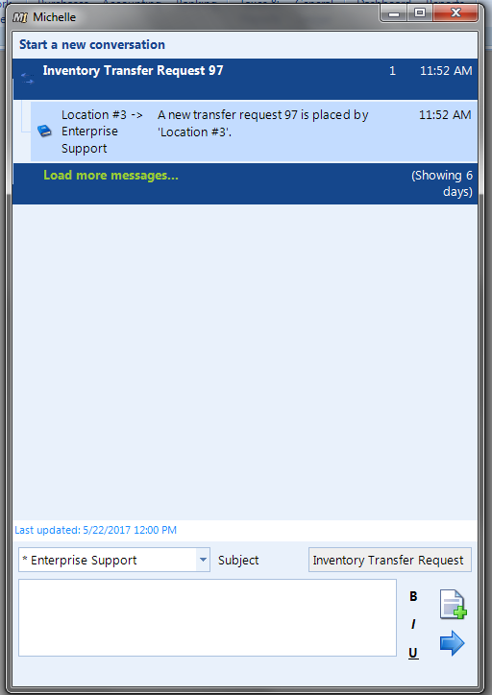

The request will also appear at the location under the Purchases module | Inventory Transfers | Incoming Requests

