DYMO Label Writer Printer Setup in Enterprise Pro

Note: You can go to Mitchell1Supplies.com if you need to purchase Refill Stickers & Printer

To download the DYMO Label Software version 8.7 please click on the following link: (see below)
Download DYMO Label Software v8.7 or higher
Note: It will be the Shops responsibility to Install DYMO Label Software 8.7 or higher, Install the printer, and customize templates included in this zip file.

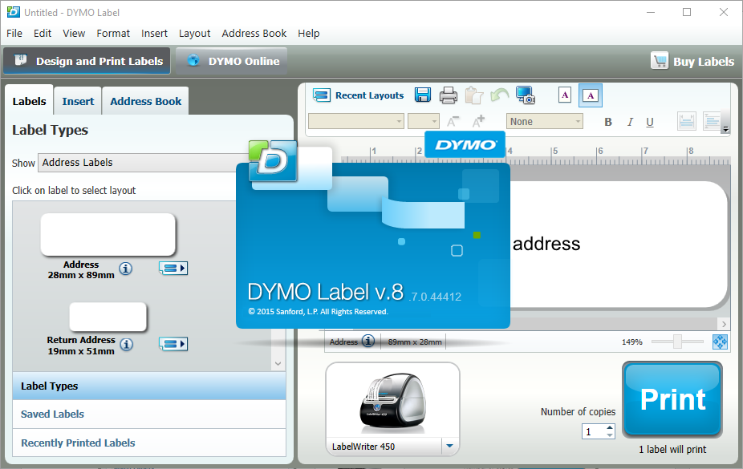

Once you have designed your label using the DYMO software please follow instructions below:

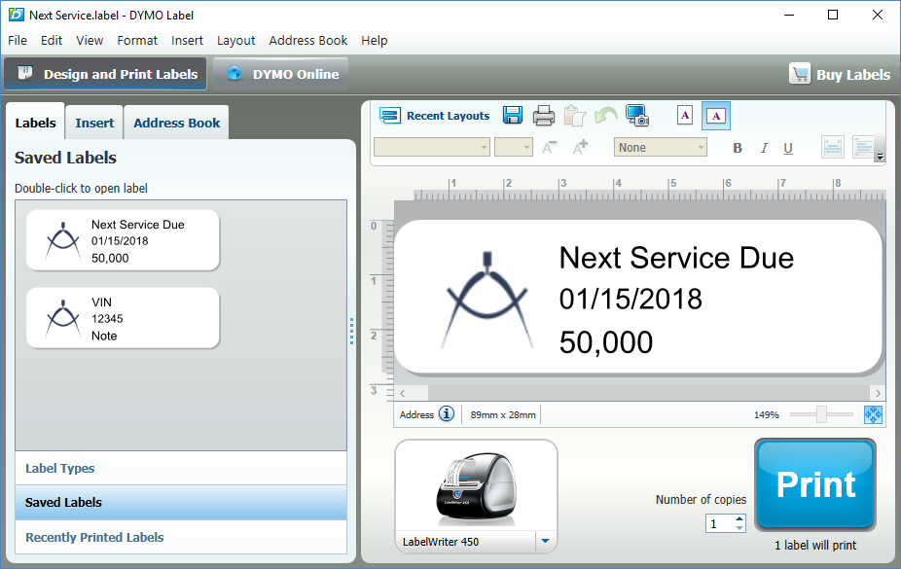

For any text fields that will be populated with shop management software’s data. Right click on the text field and click on the Edit menu and choose Object Properties.

On the “General” tab, make sure “Function as variable object” check box is selected. It is also recommended that Text scaling is set to Shrink to Fit or Auto Fit so that the space will fit the actual data.

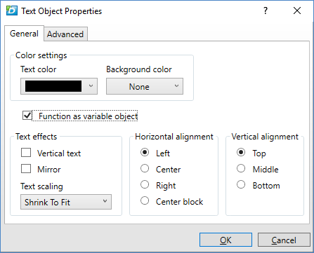
On the “Advanced” tab, in the “Reference name” field, enter one of the special field names listed in Table 1 - Supported data field names. Please make sure the field names are entered exactly as show and without any space in front, in the middle, or at the end.

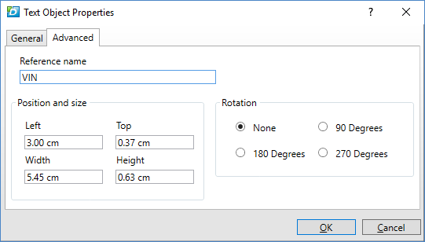

Fill in the field with some sample value and print a test label using DYMO Label software to make sure the label prints correctly.
Save the label as a file and load the label into the shop management software.
Below is a list of all support field names and what data they will be populated with if it is present on the label.

Table 1 - Supported data field names
Field Name | Description | Example
ServiceDate | The next service date as displayed on the dialog. | 1/15/2018
ServiceUsage | The next service odometer as displayed on the dialog. (0 means a blank output) | 50,000
ServiceCombined | Combined next service date and odometer. | 1/15/2018 or 50,000
VIN | The Vehicle Identification Number | 1HGBH41JXMN109186
WorkOrderNumber | The work order number. | 201234
WorkOrderNumberLast3 | The last 3 digits of the work order number. | 234
WorkOrderNumberLast4 | The last 4 digits of the work order number. | 1234
Note | The short text note entered on the dialog.

