Creating a Pricing Profile by Supplier to apply to Inventory
Step 1:
Go to Setup from the home ribbon | Pricing Profile from the left panel | Click Add on the ribbon | Enter Name for Profile (If Supplier, use Supplier Name) | Enter Type (Material or Labor) | Description Optional
Step 2:
Select Pricing Profile Rules from left column | Click the drop down arrow to select the Pricing Profile just created | Click Add from the ribbon | Price Level = Calculate the Price | Type = this is your preference | Check the box next to Supplier and Type Supplier Name in the field | Click OK | Click Save on the ribbon.

(Example below is to create Pricing Profile to apply against my Supplier “Autozone” to automatically use MSRP as Price Level)

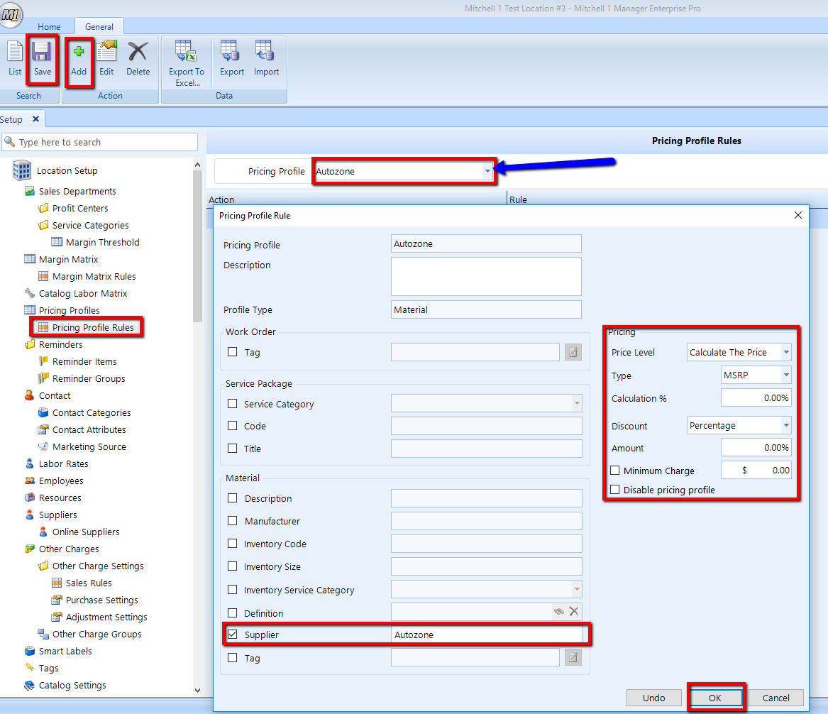

Step 3:
Next you will need to create a Pricing Profile Rule that will disable the current pricing in inventory so the system will apply the new pricing profile.
To do this you will need to add an identifying entry in all inventory material cards in the Code, Size, Manufacturer, etc. (Preferably the column that you use the least).

Example below I did a batch update to add the word “Autozone” to all Inventory Materials in the “Size” column
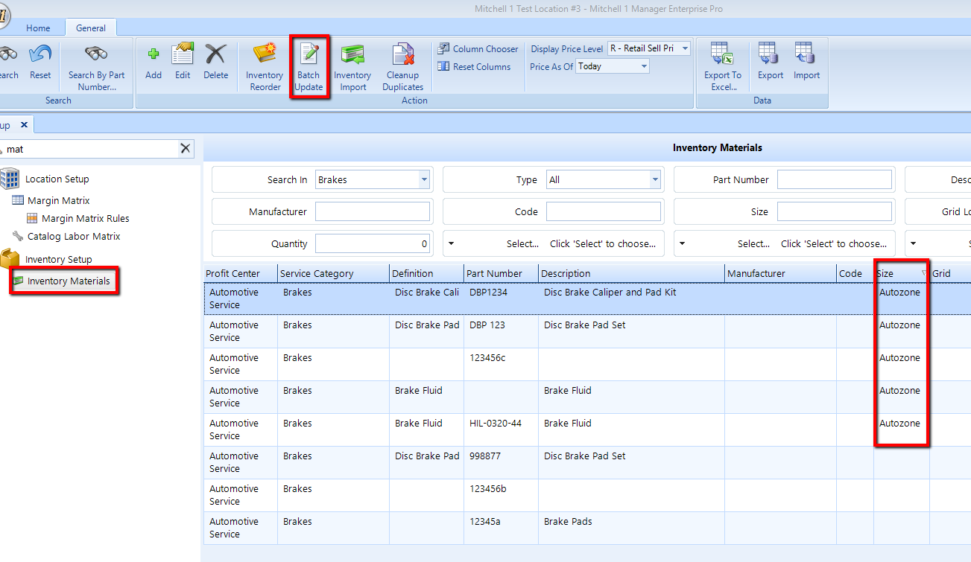

Next go to Pricing Profile Rules in Setup | Select the Pricing Profile you created in Step 1| Click Add from the ribbon | Check box next to Disable Pricing Profile | Click OK | Save |
Step 4:
Note: “Disabled” Pricing Profile Rule must appear in the list first so the system will disable the Pricing Profile to all inventory items with the Identifying entry first before applying the next rule.
Example in image above is telling the system to disable the pricing for all inventory with “AutoZone “in the “Size” field.
Click on the line item for the “Disable” rule and drag it to the top of the list (Top line in highlighted entry will turn Red to indicate the drag feature enabled) | Click Save on the ribbon.

Step 5:
Go to Setup from the home ribbon | Location Settings from the left panel | Select Contact tab | Default Pricing Profile | Click the appropriate drop down to select the Profile to make this the default profile for all Contacts. (See image below)



